

Mtel (Thailand) Co., Ltd.

For

T.C.C. Technology Co., Ltd.

One Bangkok Mobile Application
Common Feature
To
T.C.C. Technology Co., Ltd.

Total 34 sheets (w/h cover sheet)
 | PROJECT NAME | JOB NO. | DOCUMENT NO. | REV.
 | One Bangkok Mobile Application - Common Feature Document |  |  | 01

Home

User flow diagram

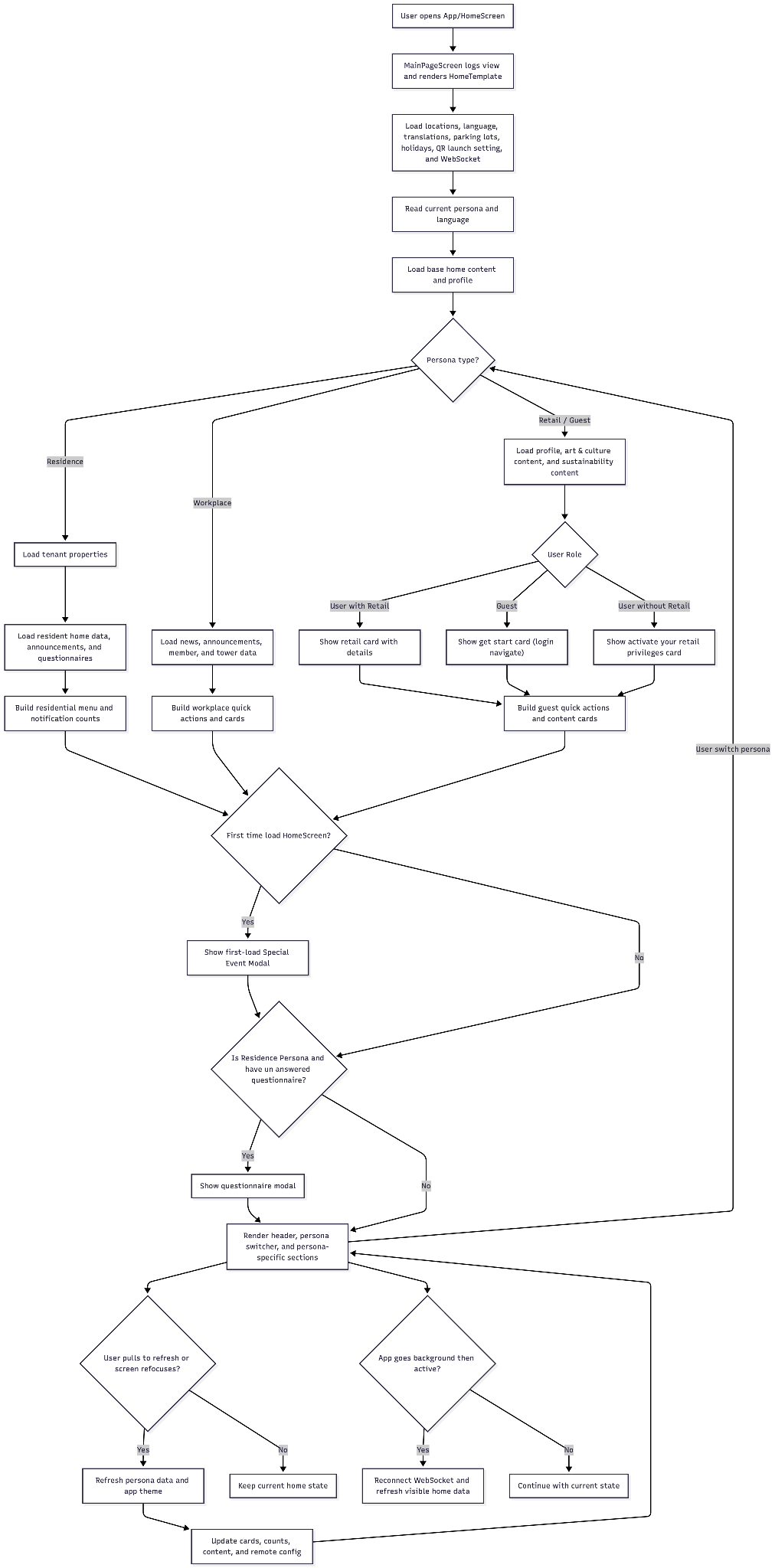

Sequence diagram

HomeTemplate Sequence Diagram.png

AQI

User flow diagram

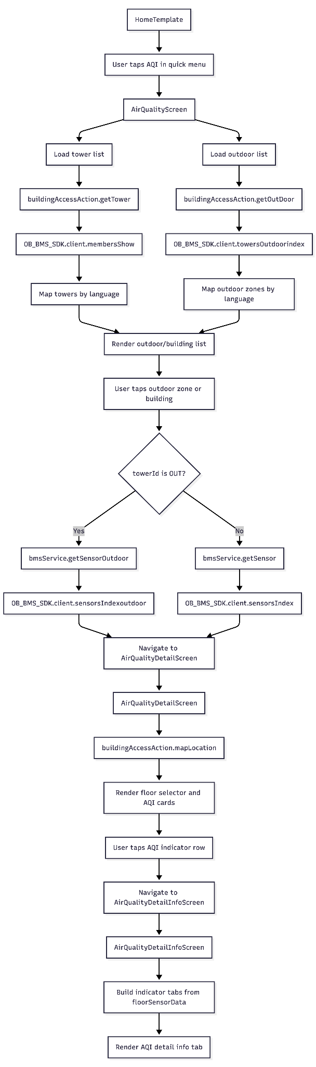

Sequence Diagram
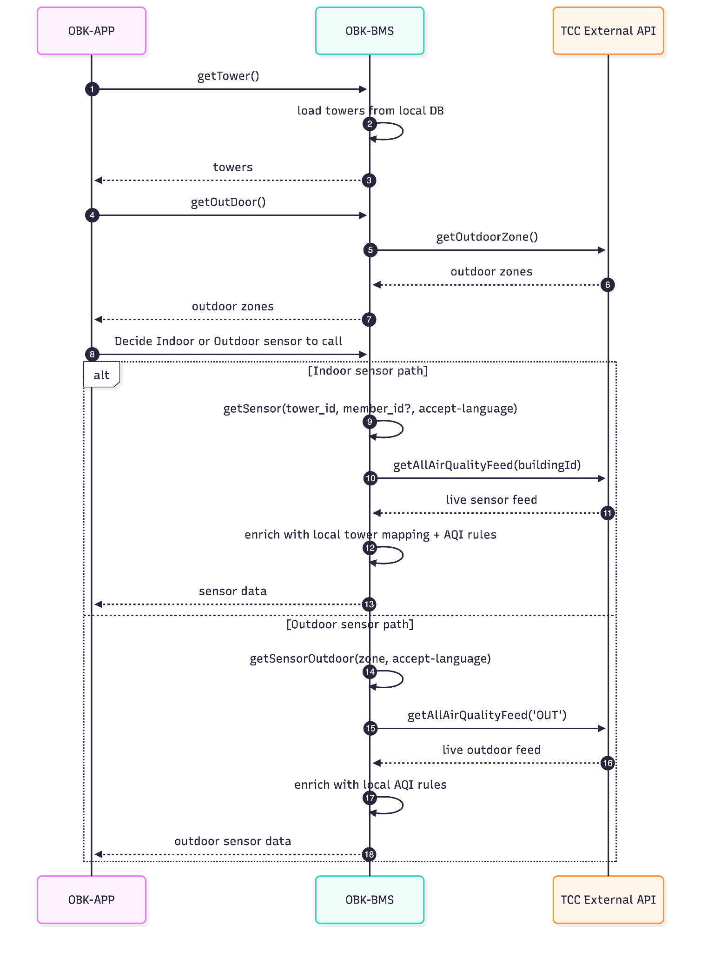

API Document
- Response wrapper:

{
"data": ...
}

- Sensor endpoints support the accept-language header:
  - en
  - th
  - cs
  - defaults to en
- The sensor endpoints are alternative paths:
  - indoor sensors use GET /sensors
  - outdoor sensors use GET /sensors/outdoor
- GET /towers/outdoor is a supporting endpoint for outdoor zone metadata
- No explicit auth guard is visible in the controller code for these endpoints

==================================================================

Tower Module
==================================================================

GET /towers
Description: Retrieve towers with floor data from the local database

Example Request:
GET /towers
Example Response:
{
"data": [
{
"id": "tower-1",
"uid": "TWR-001",
"name": "Tower A",
"display_name": {
"en": "Tower A",
"th": "Tower A"
},
"project_id": "project-1",
"created_at": "2026-04-30T00:00:00.000Z",
"updated_at": "2026-04-30T00:00:00.000Z"
}
]
}

GET /towers/outdoor
Description: Retrieve outdoor zone metadata used by the outdoor sensor flow
Example Request:
GET /towers/outdoor
Example Response:
{
"data": [
{
"code": "OUT",
"display_name": {
"en": "One Bangkok Park",
"th": "วัน แบงค็อก ปาร์ค",
"zh": "null"
},
"id": "ONE_BANGKOK_PARK",
"name": "One Bangkok Park"
}
]
}

Implementation Notes:
- This endpoint calls the external TCC outdoor-zone API through TowerService.index()
- The result is mapped into a normalized outdoor zone structure

==================================================================

Sensor Module
==================================================================

GET /sensors
Description: Retrieve indoor sensor readings for a tower
Query Parameters:
- tower_id (string, required): Tower ID used to fetch the corresponding sensor building mapping
- member_id (string, optional): If present, the response is limited to floors authorized for that member
Headers:
- accept-language (string, optional): Language used for AQI indicator labels
Example Request:
GET /sensors?tower_id=tower-1&member_id=member-1
Example Response:
{
"data": [
{
"floors": [
{
"floor_id": "floor-1",
"sensors": [
{
"tower_id": "tower-1",
"floor_id": "floor-1",
"zone_id": "mock",
"sensor_type": "pm25",
"value": "12",
"unit": "",
"updated_at": "2026-04-30T00:00:00.000Z",
"indicator": "Good",
"color_code": "#00A650"
}
]
}
],
"indicator": [
{
"id": "aqi-1",
"name": "PM2.5",
"display_name": {},
"short_description": {},
"description": {},
"sequence": 1,
"created_at": "2026-04-30T00:00:00.000Z",
"updated_at": "2026-04-30T00:00:00.000Z",
"air_quality_index_indicator": []
}
]
}
]
}

Implementation Notes:
- SensorsController.index() resolves optional member-floor access before calling the service
- SensorService.find():
  - gets live air-quality feed from the external TCC API
  - loads the tower mapping from the local database
  - loads AQI rules from the local database
  - maps readings to floors
  - derives indicator and color_code from AQI ranges
- The response is grouped by floor

GET /sensors/outdoor
Description: Retrieve outdoor sensor readings for a specific outdoor zone
Query Parameters:
- zone (string, required): Outdoor zone name used to filter the live feed
Headers:
- accept-language (string, optional): Language used for AQI indicator labels
Example Request:
GET /sensors/outdoor?zone=PARKING_ZONE
Example Response:
{
"data": [
{
"floors": [
{
"floor_id": "OUT-01",
"sensors": [
{
"tower_id": "OUT",
"floor_id": "OUT-01",
"zone_id": "Parking Zone",
"sensor_type": "pm25",
"value": "18",
"unit": "",
"updated_at": "2026-04-30T00:00:00.000Z",
"indicator": "Moderate",
"color_code": "#FFD200"
}
]
}
],
"indicator": [
{
"id": "aqi-1",
"name": "PM2.5",
"display_name": {},
"short_description": {},
"description": {},
"sequence": 1,
"created_at": "2026-04-30T00:00:00.000Z",
"updated_at": "2026-04-30T00:00:00.000Z",
"air_quality_index_indicator": []
}
]
}
]
}

Implementation Notes:
- SensorService.findOutdoor() calls the external TCC air-quality feed for building OUT
- The feed is filtered by the requested zone
- AQI indicator definitions are loaded from the local database
- The response is grouped by floor_id

Data Flow Summary
- GET /towers reads tower and floor data from the local database
- GET /towers/outdoor reads outdoor zone metadata from TCC
- GET /sensors reads live feed from TCC and enriches it with local tower and AQI data
- GET /sensors/outdoor reads live outdoor feed from TCC and enriches it with local AQI data

Bookmark

User flow diagram
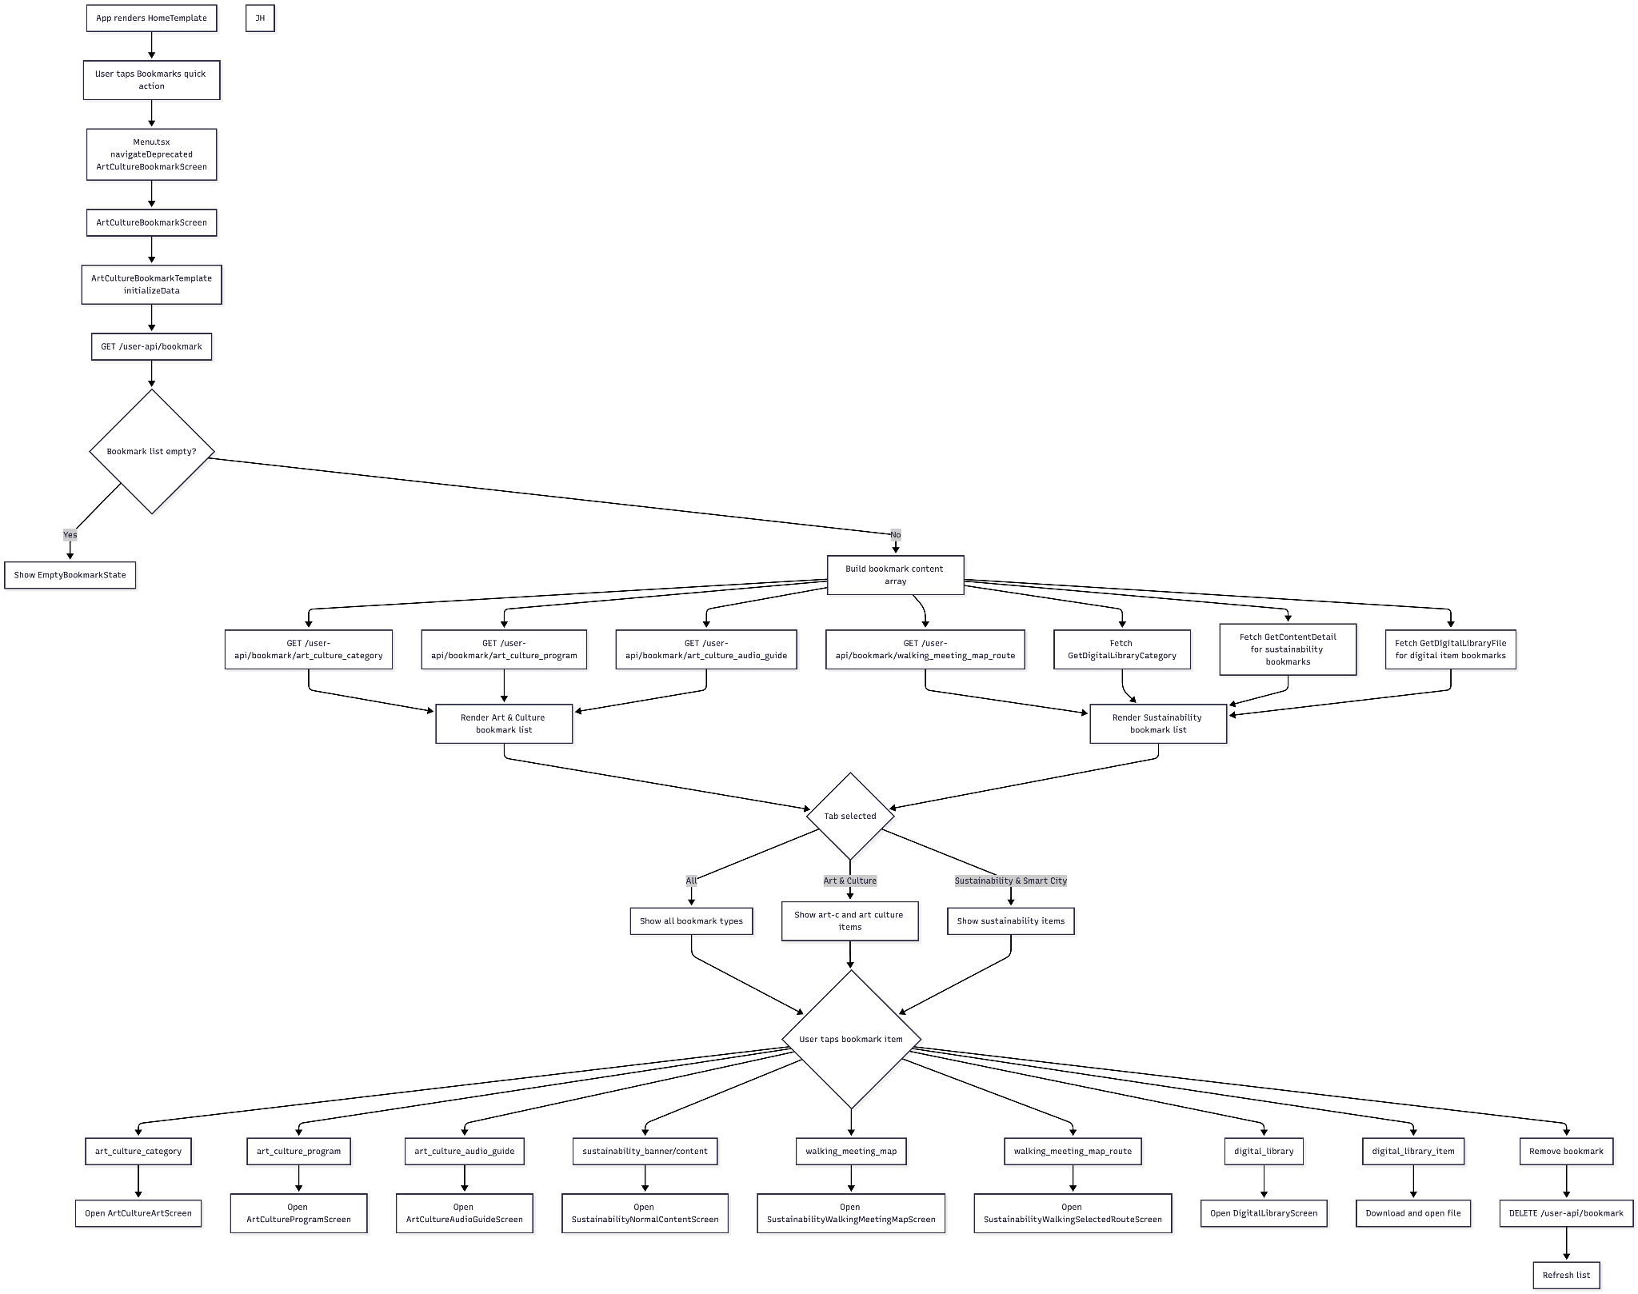

Sequence Diagram
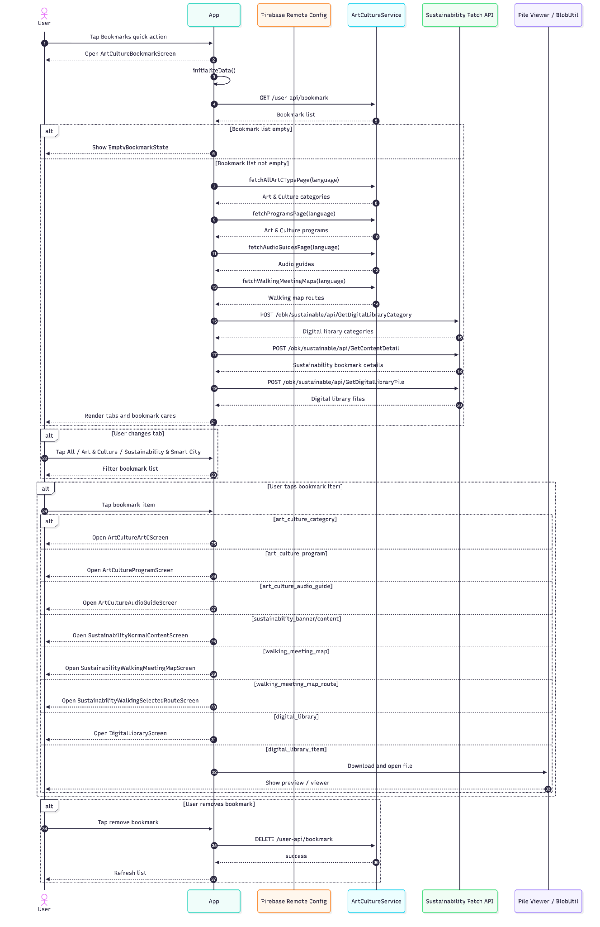

EV Shuttle Bus

User flow diagram
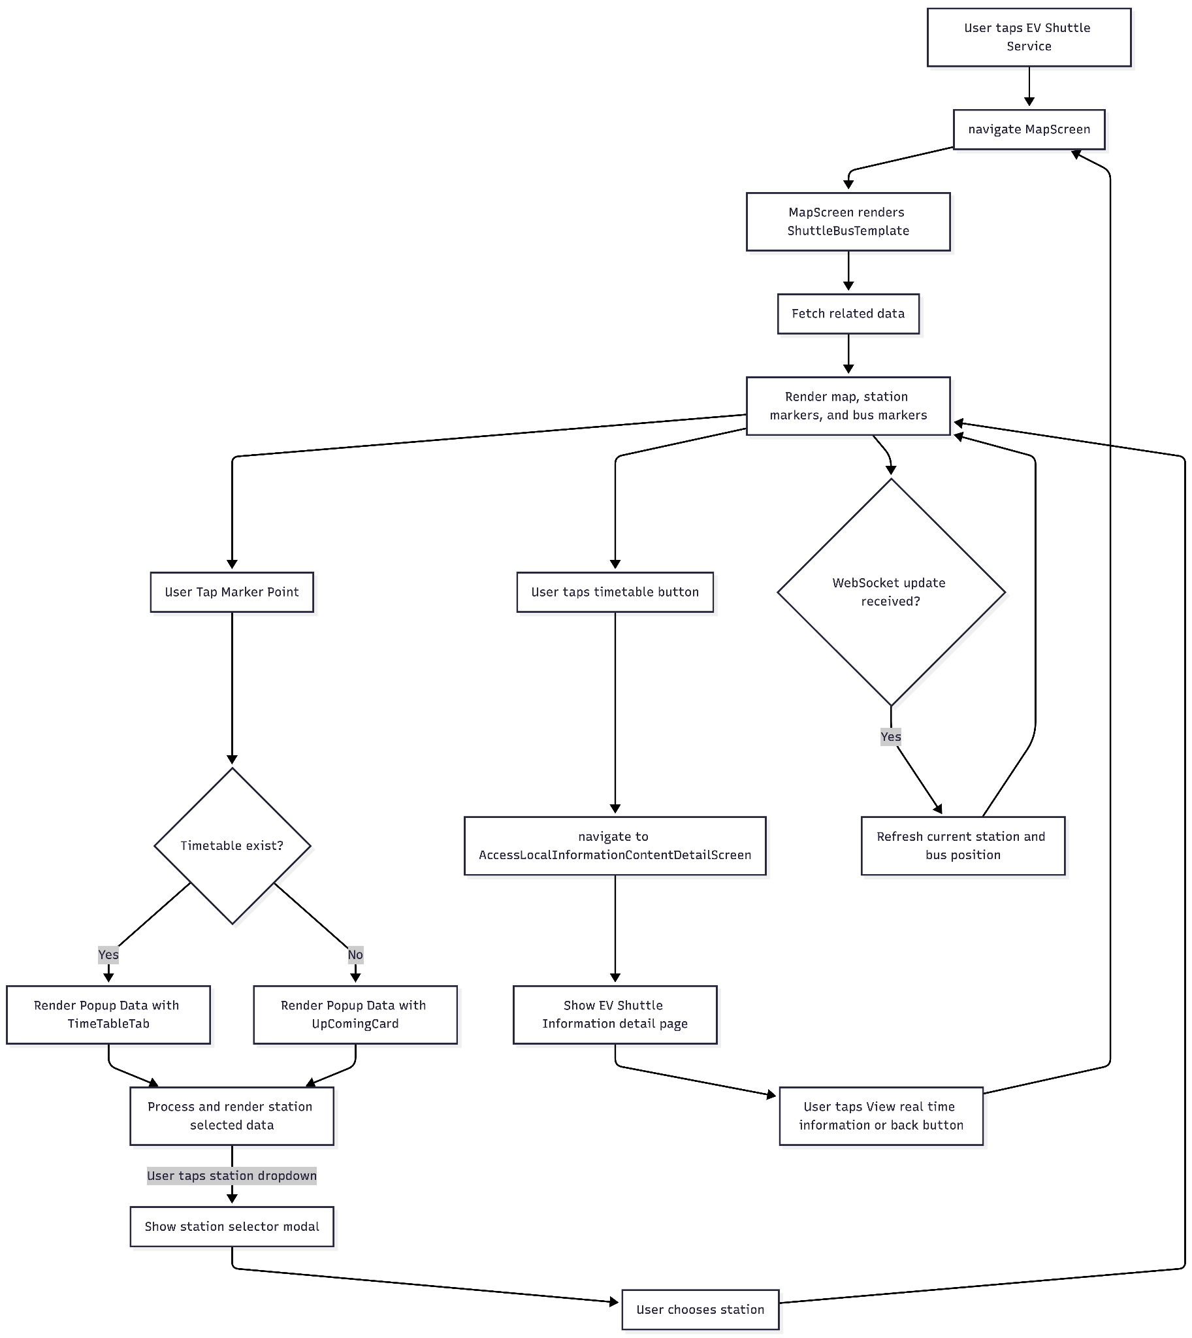

Sequence Diagram
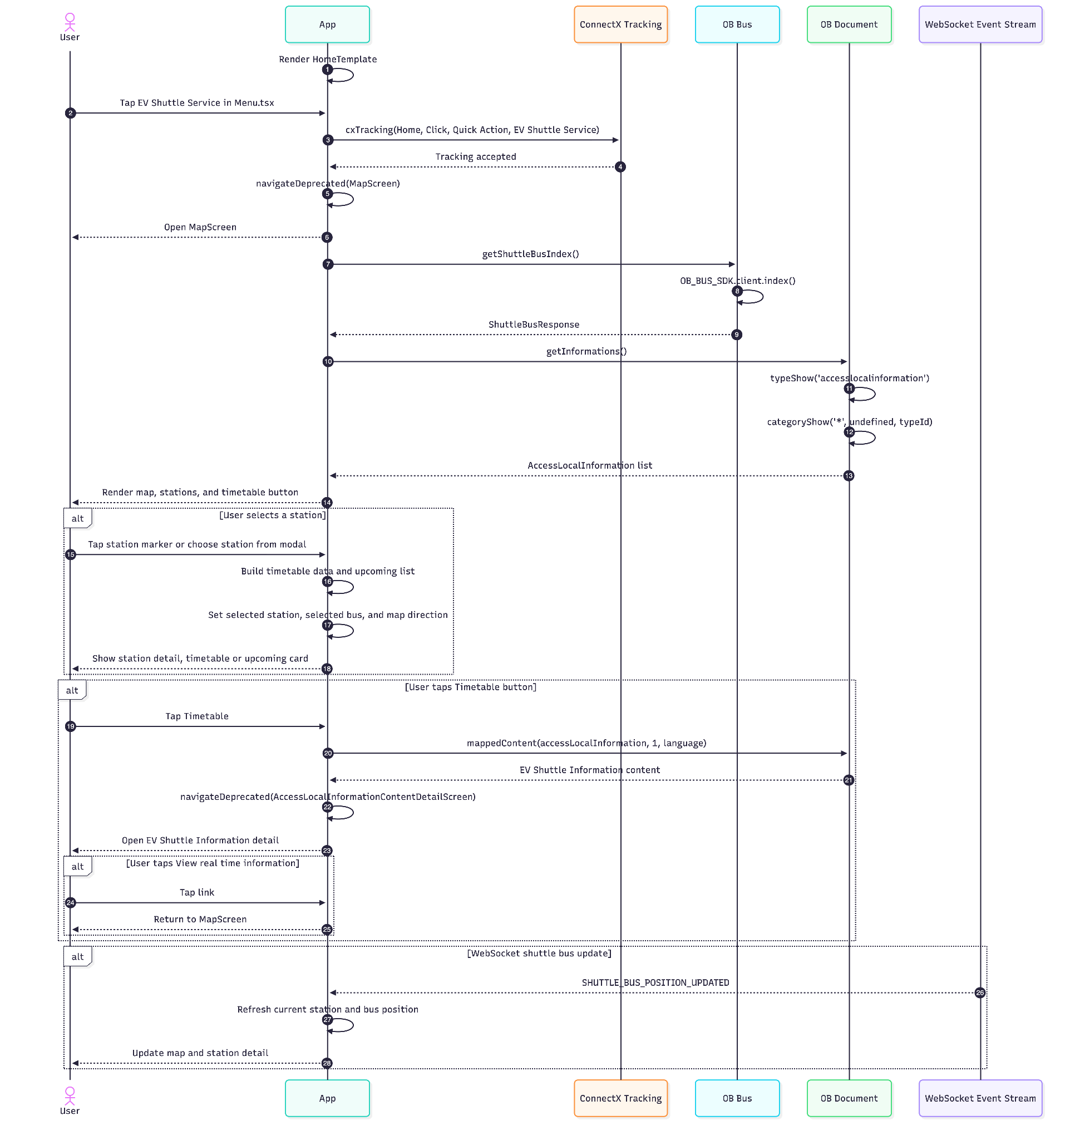

OB-BUS ER Diagram
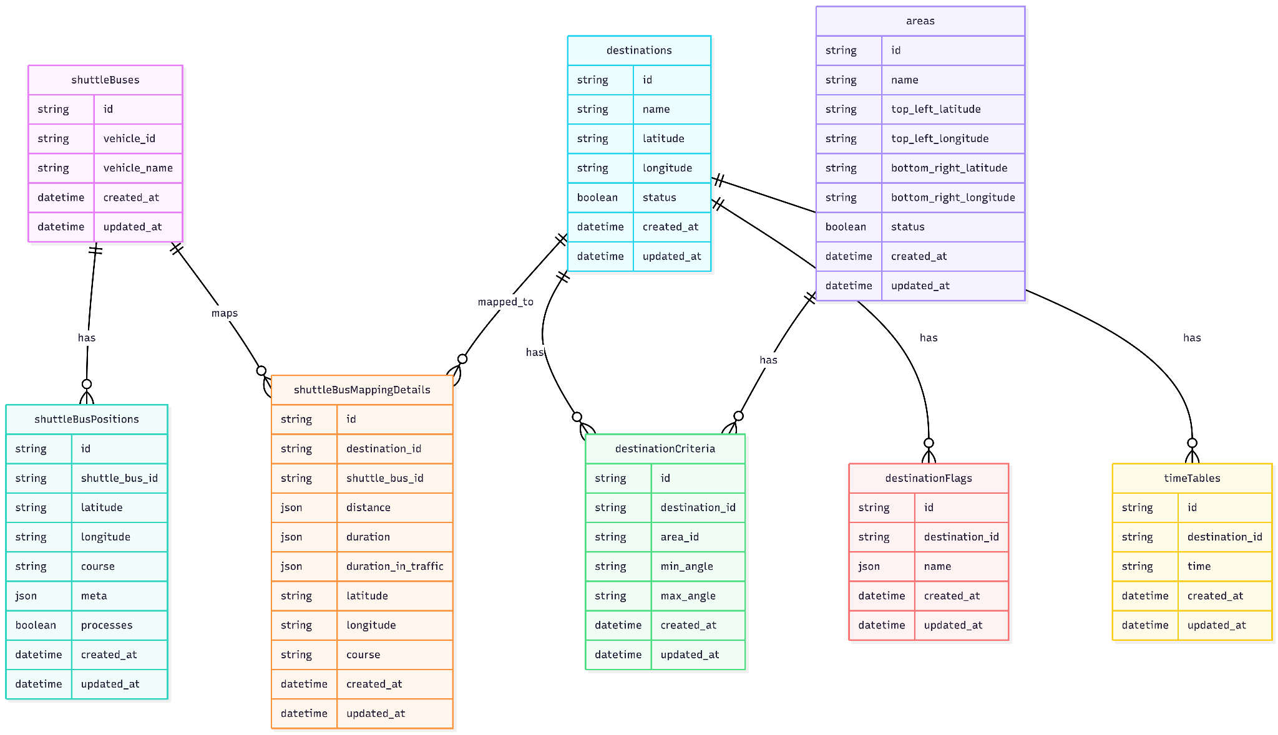

OB-BUS API Document

Global API Behavior
- Base path prefix: none
- Swagger UI: /docs
- Health/root check: GET /
- CORS: enabled for all origins
- Body parsing: application/json and application/x-www-form-urlencoded
- Logging middleware is applied globally
- TSOA generates the route bindings from controller decorators

Authentication / Authorization
- The Montri webhook endpoints use the Authorizer middleware
- Required header: x-permissions
- The header value is expected to be a base64-encoded JSON payload containing a permission collection
- The request is accepted only when a permission matches:
  - resource_type = "montri"
  - actions contains "*"

Response wrappers
Most success responses use this shape:

{
"data": ...
}

Task endpoints return a boolean result inside data:

{
"data": {
"result": true
}
}
Error responses are handled centrally by the middleware layer:
{
"error": {
"code": "BUS_DES_001",
"message": "Bus cannot find the destination"
}
}

======================================================================App Module
======================================================================

GET /
Description: Health check for the service.
Example Request:
GET /
Example Response:
200 OK
Example Response Body:
{}

GET /docs
Description: Swagger UI for the TSOA-generated API specification.
Example Request:
GET /docs
Example Response: HTML Swagger UI page.

======================================================================

Montri Webhook Module
======================================================================

POST /integrations/montri/webhook
Description: Ingest a Montri webhook event and store a new shuttle bus position.
Authorization:
Header: x-permissions
Required permission: resourceType: "montri" and action: "*"
Request Body:
action (string, required): Event name
payload (object, required): Shuttle bus telemetry payload
Supported Action:
shuttle_bus_position.updated
Example Request:
{
"action": "shuttle_bus_position.updated",
"payload": {
"imei_id": "123456789012345",
"latitude": 13.7563,
"longitude": 100.5018,
"course": 90,
"server_time": "2026-05-06T09:00:00Z",
"gps_time": "2026-05-06T09:00:00Z",
"vehicle_id": "bus-001",
"device_id": "device-001",
"version_id": "v1",
"vendor_id": 1,
"chassis_number": "CH-001",
"mobileunitid": "MU-001",
"imei_sim": "sim-001",
"ccid_number_sim": "ccid-001",
"firmware_version": 1,
"data_status": "OK",
"gps_status": 1
}
}

Notes:
- The service stores the bus by payload.imei_id
- The entire payload is persisted as JSON metadata with the position record
- Additional telemetry fields may be included; the controller accepts the full Montri payload shape

Success Response:
- HTTP 200
- No response body

Error Scenarios:
Status | Scenario | Response error.code | Response error.message
401 | Missing or invalid x-permissions header | OB_006 | unauthorized
400 | Unsupported webhook action | BUS_INT_001 | Type mismatch
500 | Unhandled processing failure | OB_001 | internal server error

POST /v2/integrations/montri/webhook
Description: Versioned Montri webhook endpoint that just create or update data in shuttleBuses and shuttleBusPositions.
Authorization:
- Same as POST /integrations/montri/webhook
Request Body:
- Same as POST /integrations/montri/webhook
Example Request:
{
"action": "shuttle_bus_position.updated",
"payload": {
"imei_id": "123456789012345",
"latitude": 13.7563,
"longitude": 100.5018,
"course": 90
}
}

Success Response:
- HTTP 200 (No response body)
======================================================================

Task Module
======================================================================

POST /task/delete_bus_position
Description: Delete shuttle bus positions older than 30 minutes.
Request Body:
- No request body
Example Request:
POST /task/delete_bus_position
Example Response:
{
"data": {
"result": true
}
}

Notes:

- Returns false when no rows were deleted
- This endpoint is intended for scheduled jobs or operational triggers

POST /task/process_bus_position
Description: Process the latest bus positions, map buses to destinations, and broadcast the serialized station payload.
Request Body:
- No request body
Example Request:
POST /task/process_bus_position
Example Response
{
"data": {
"result": true
}
}
Processing Steps:
- Load all shuttle buses
- Fetch each bus's latest unprocessed position
- Match position coordinates against active area boundaries
- Match course against destination angle criteria
- Call Google Distance Matrix for distance and ETA values
- Upsert shuttle_bus_mapping_details
- Broadcast the updated station payload to the WebSocket backend

Error Scenarios:
Status | Scenario | Response error.code | Response error.message
500 | No shuttle buses exist | BUS_DES_001 | Bus cannot find the destination
500 | Bus position is outside all defined areas | BUS_ARE_001 | Bus is not in calculated area
500 | Destination cannot be determined from course | BUS_DES_001 | Bus cannot find the destination
500 | Google Maps response is missing distance data | BUS_GOG_001 | Cannot find data on google map distance api
500 | Unexpected processing failure | OB_001 | internal server error

Shuttle Bus Module
======================================================================

GET /shuttle-bus
Description: Return the current shuttle bus station snapshot grouped by destination.
Request Body:
No request body
Example Request:
GET /shuttle-bus
Example Response:

{
"data": {
"stations": [
{
"latitude": "13.7563",
"longitude": "100.5018",
"name": "Central Station",
"shuttleBusDetail": [
{
"origin": {
"latitude": "13.7550",
"longitude": "100.5000"
},
"destination": {
"latitude": "13.7563",
"longitude": "100.5018"
},
"duration": {
"text": "5 mins",
"value": "300"
},
"duration_in_traffic": {
"text": "7 mins",
"value": "420"
},
"distance": {
"text": "1 km",
"value": "1000"
},
"detail": {
"id": "bus-001",
"name": "Shuttle 1"
},
"course": "90"
}
],
"time": [
{
"time": "08:00"
},
{
"time": "09:00"
}
],
"flag": {
"name": ["weekday"]
}
}
]
}
}

Response Notes:

- shuttleBusDetail is sorted by ascending duration.value
- flag.name is derived from the first destination flag entry
- time is built from the station's timetable rows ordered by time

Important Data Models
- shuttleBuses stores each vehicle identity
- shuttleBusPositions stores raw telemetry points
- areas stores bounding boxes used for geo matching
- destinationCriteria links areas to destinations and course ranges
- destinations stores the station/location records
- shuttleBusMappingDetails stores the latest bus-to-destination mapping and travel metadata
- destinationFlags and timeTables enrich the station response

My QR

User flow diagram

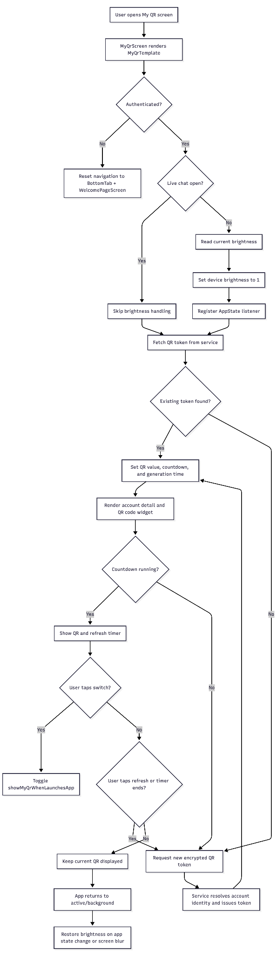

Sequence diagram

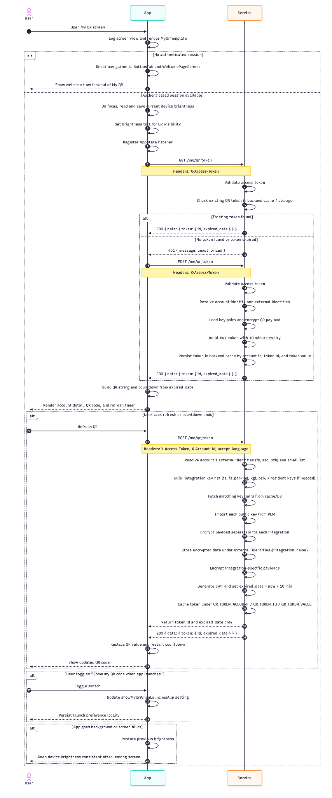

OneBangkok Map

User flow diagram

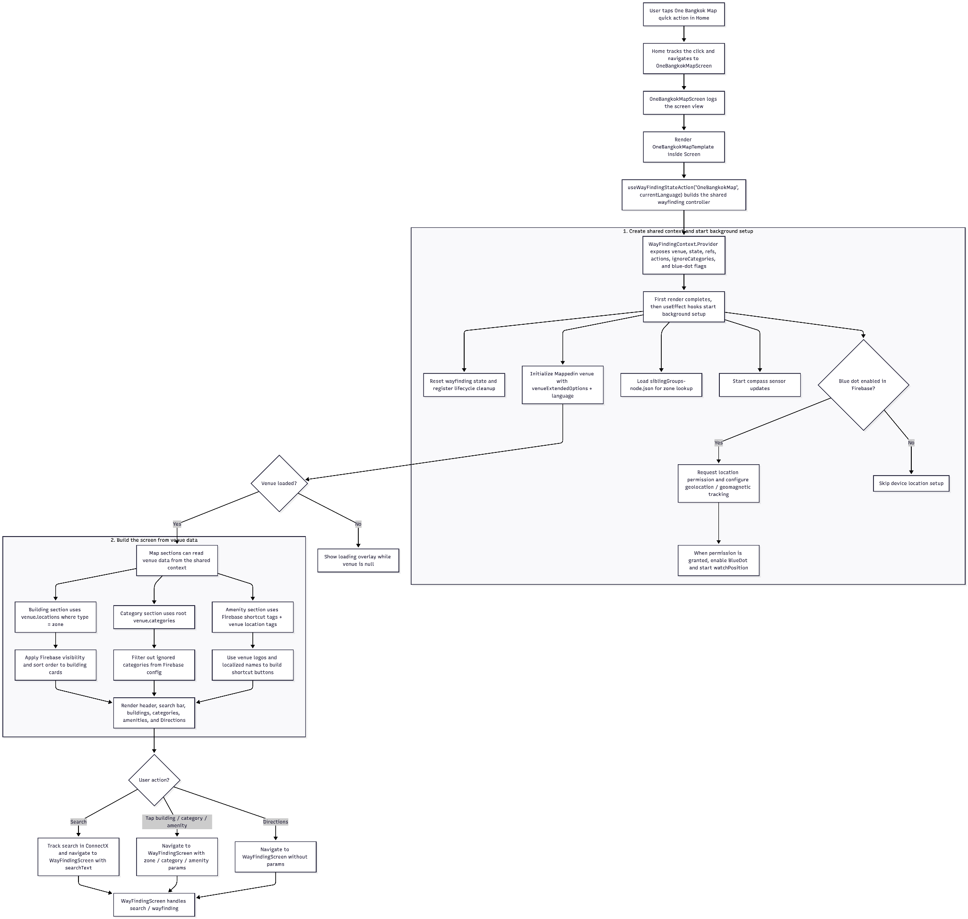

Sequence diagram
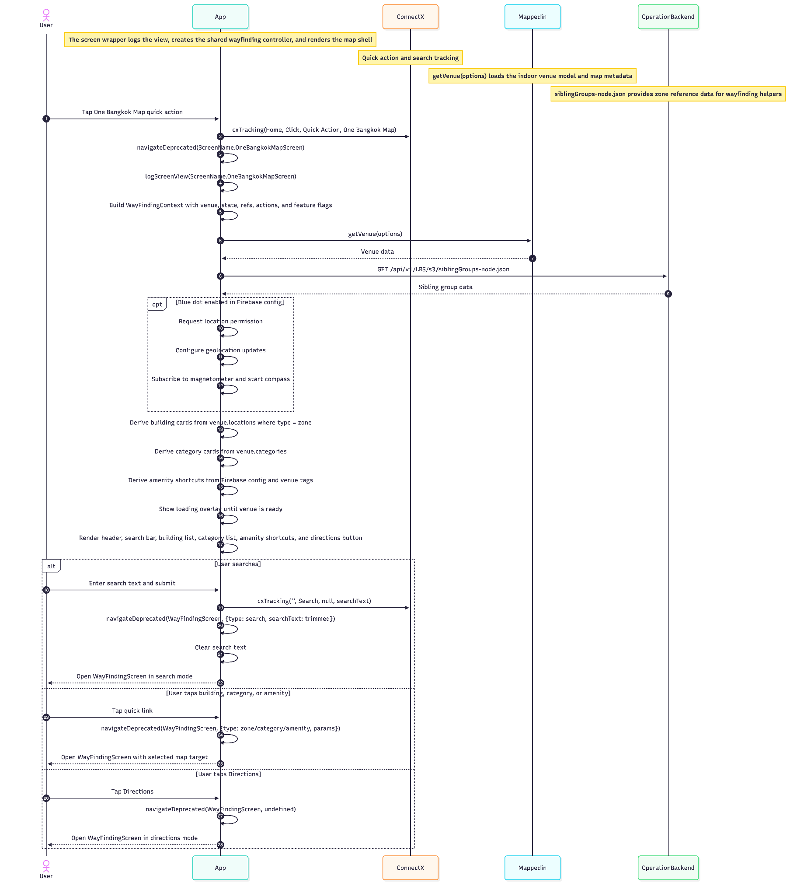

Shop And Dine

User flow diagram
